Matcont progress

Finally got the model working – 5/20/20 1:08pm

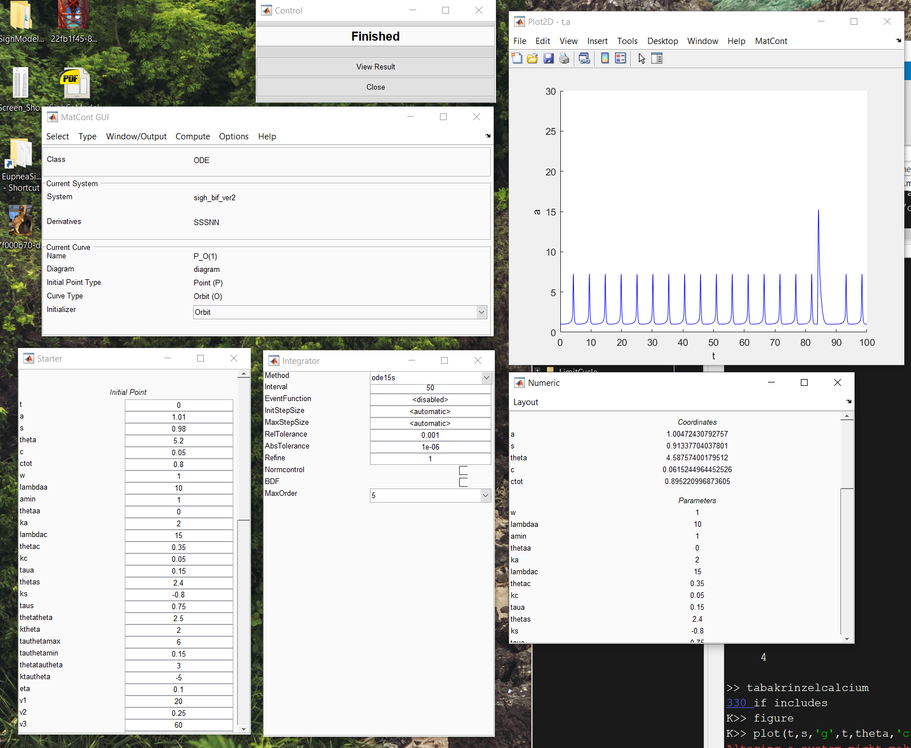

Now going for initial point 🡪 equilibrium. But getting an error. “No convergence at x0”. Possible causes:

* The final point I am picking is not at or near an equilibrium?
* Problem with the integrator?
* Or not run long enough?
* Helpful link <http://www.math.ubc.ca/~keshet/Papers/LPA_BJTools_Supp2.pdf>, ctrl+f “no convergence”

I hypothesize the issue is caused by the sharp trajectory change in *a* when a sigh happens. Note the sharp crease in the trajectory. Compare that to the 2 state Ca model.

